Lab 2

Jeremy Scheuerman

Dr. Peter Wang

Lab 2

2.1

Ex 1

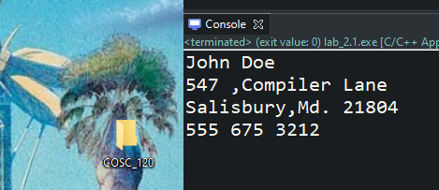

Ex 2

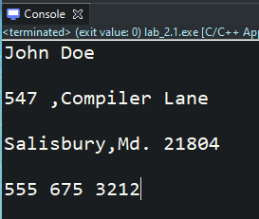

Ex 3

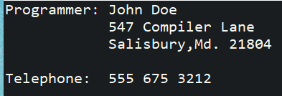

**#include** <iostream>

**using** **namespace** std;

**int** main()

{

cout << "Programmer: John Doe" << endl;

cout << " 547 Compiler Lane" << endl;

cout << " Salisbury,Md. 21804\n" << endl;

cout << "Telephone: 555 675 3212" << endl;

**return** 0;

}

Lab 2.2

Ex1 :

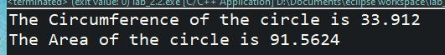

EX 2

// This program will output the circumference and area// of the circle with a given radius.// PLACE YOUR NAME HERE

**#include** <iostream>

**using** **namespace** std;

**const** **double** PI = 3.14;

**const** **double** RADIUS = 5.4;

**int** main() {

**float** area;

// definition of area of circle

Float circumference;

// definition of circumference

circumference = 2 * PI * RADIUS;

// computes circumference

area = PI * (RADIUS * RADIUS); // computes area

// Fill in the code for the cout statement that will output (with description)

cout << "The Circumference of the circle is " << circumference << endl;

// the circumference// Fill in the code for the cout statement that will output (with description)

cout << "The Area of the circle is " << area << endl;

// the area of the circle

**return** 0;

}

Ex3:

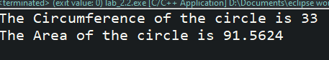

Lab 2.3

Ex1

// This program will output the circumference and area// of the circle with a given radius.// PLACE YOUR NAME HERE

**#include** <iostream>

**using** **namespace** std;

**const** **double** length = 8;

**const** **double** width = 3;

**int** main() {

**float** area;

// definition of area of rectangle

**float** perimeter;

// definition of perimeter

perimeter = (2 *length)+ (2*width);

// computes circumference

area = length*width; // computes area

// Fill in the code for the cout statement that will output (with description)

cout << "The Perimeter of the rectangle is " << perimeter << endl;

// the circumference// Fill in the code for the cout statement that will output (with description)

cout << "The Area of the rectangle is " << area << endl;

// the area of the rectangle

**return** 0;

}

Ex 2

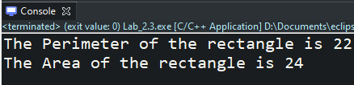

Lab 2.4

Ex1

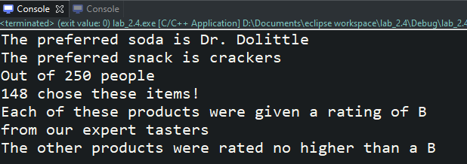

Ex2

// This program demonstrates the use of characters and strings

// PLACE YOUR NAME HERE

**#include** <iostream>

**#include** <string>

**using** **namespace** std;

// Definition of constants

**const** string FAVORITESODA = "Dr. Dolittle"; // use double quotes for strings

**const** **char** BESTRATING = 'A'; // use single quotes for characters

**int** main() {

**char** rating = 'B'; // 2nd highest product rating

string favoriteSnack = "crackers"; // most preferred snack

**int** numberOfPeople = 250; // the number of people in the survey

**int** topChoiceTotal = 148;// the number of people who prefer the top choice

// Fill in the code to do the following:

// Assign the value of "crackers" to favoriteSnack

// Assign a grade of 'B' to rating

// Assign the number 250 to the numberOfPeople

// Assign the number 148 to the topChoiceTotal

// Fill in the blanks of the following:

cout << "The preferred soda is " << FAVORITESODA << endl;

cout << "The preferred snack is " << favoriteSnack << endl;

cout << "Out of " << numberOfPeople << " people " << endl;

cout << topChoiceTotal << " chose these items!" << endl;

cout << "Each of these products were given a rating of " << rating << endl;

cout << "from our expert tasters" << endl;

cout << "The other products were rated no higher than a " << rating << endl;

**return** 0;

}

Ex3:

No, because it is a constant and cannot be changed during execution

Ex4:

Yes, because it is not a constant therefore it can be changed during execution